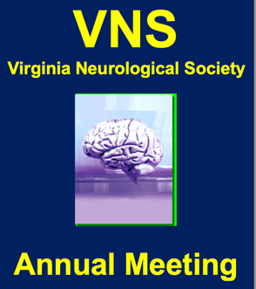
Virginia Neurological Society Annual Meeting
January 18-21, 2024
Omni Homestead Resort, Hot Springs, VA

Program Overview and Target Audience:
The educational sessions of the VNS Annual Meeting are intended for neurologists and address the American Board of Psychiatry and Neurology core competencies in patient care and medical knowledge.

Desired Outcomes:
Upon completion of this live activity, participants will be able to:
- Discuss the use of “traditional” immunotherapies and results from recent clinical trials in MG, CIDP, GBS, and myositis.
- Apply the guidelines for use, dose initiation, adverse reactions, monitoring parameters, and future immunotherapies in neuromuscular disease.
- Contrast the manifestations and diagnosis of uncommon monogenic vs. polygenic stroke and cerebrovascular disease and potential treatments.
- Discuss approaches to neuroprognostication, including predictor reliability in comatose survivors and emerging technologies that may enhance prognostication accuracy in cardiac arrest survivors.
- Apply the 2023 updates to brain death determination and discuss ethical considerations surrounding the withdrawal of life sustaining treatment.
- Discuss indications, exclusion criteria, adverse and expected therapeutic effects of approved anti-amyloid therapies and the resources necessary to administer and manage monoclonal antibody therapies.
- Describe the classifications, forms, symptoms, and management of patients with ARIA, to differentiate ARIA from other common acute neurological syndromes,
- Discuss the narcolepsy pathophysiology, symptoms, and management and distinguish from the rare but similar disorder, Kleine-Levin Syndrome (KLS).
- Describe the current landscape of AI technology in medicine, including challenges and limitations and opportunities to integrate emerging technologies into clinical neurological practice.

Agenda
Thursday, January 18, 2024

4:00-6:00pm VNS Executive Committee Meeting Madison Room

6:30-7:30pm Opening Reception Washington Library

Friday, January 19, 2024

8:30am Registration Garden Room
Coffee/Exhibits Crystal Ballroom

8:55-9:00am Welcome and Program Overview Empire Room

Scientific Session Matthew Barrett, MD, Session Moderator

9:00-9:45am Updates in Immunotherapies in Neuromuscular Diseases
Qihua Fan, MD, Richmond, VA

9:45-10:30am A Case-based Approach or Uncommon Beasts and How to Find Them: Rare Genetic
Causes of Stroke Bradford Worrall, MD, Charlottesville, VA

10:30-11:00am Break: Visit Exhibitors Crystal Ballroom

11:00-11:45am Prognostication After Cardiac Arrest and Brain Death Determination
Shraddha Mainali, MD, Richmond, VA

11:45-12:30pm The Changing Landscape of Alzheimer’s Therapeutics

Roberto Fernandez-Romero, MD, MPH, PhD, Knoxville, TN
Clinical Pathological Correlations (CPC) Myla Goldman, MD, Session Moderator Empire Room

5:30-6:30pm Presenters
Mark Quigg, MD, Charlottesville, VA,
Myla Goldman, MD, Richmond, VA
Matthew Barrett, MD, Richmond, VA

6:30-7:30pm Reception Commonwealth Room

Saturday, January 20, 2024

9:00-9:30am Registration Garden Room
Coffee/ Exhibits Crystal Ballroom

Practice of Neurology Myla Goldman, MD, Session Moderator Empire Room

9:30-10:30am Narcolepsy in Context: History, Diagnosis and Management
Samuel Taylor, MD, Richmond, VA

10:30-11:00am Break: Visit Exhibitors Crystal Ballroom

11:00-12:30pm Annual Business Meeting Empire Room

Fritz Dreifuss Lecture Donald Taylor, MD, Session Moderator Empire Room

5:30-6:30pm Will AI Replace Neurologist? Navigating the Neural Nexus of AI and Neurology
Tayab Waseem, MD, PhD Washington, DC

**Drawing for winner of 2 nights lodging at the Omni Homestead Resort**

6:30pm Annual Group Photograph Crystal Ballroom

6:30-7:30 pm President’s Reception Washington Library
MEMBERS AND GUESTS ONLY Hosts: Dr. and Mrs. Donald Taylor

Sunday, January 21, 2024

9:00-11:00am Difficult Cases-Neurology Consult - Richard Seestedt, MD, Session Moderator - Empire Room

Daniela Fishbein, MD, Resident, UVA, Charlottesville, VA
Shital Patel, MD, Resident, VCU, Richmond, VA
Geetika Bajpai, MD, Resident, VTC, Roanoke, VA

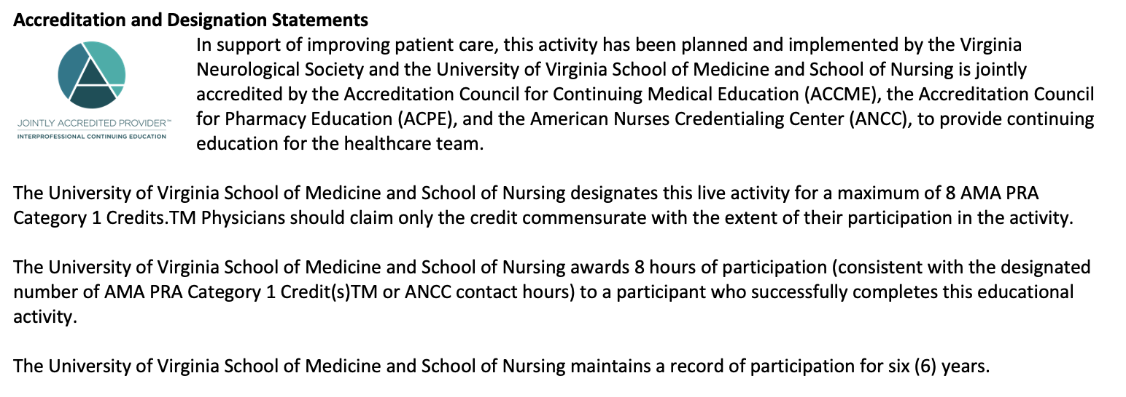

Jointly Provided by the University of Virginia School of Medicine and School of Nursing and the Virginia Neurological Society.

Course Director: *Sona Pomfret, Executive Director, Virginia Neurological Society

Faculty and Planning Committee (*):

Shital Patel, MD
Virginia Commonwealth University

*Elizabeth Patterson, MEd
UVA Schl of Medicine, Office of CCME

Mark Quigg, MD, MSc, FANA
Medical Director, Neurophysiology Labs
TR Johns Professor of Neurology

*Donald Taylor, MD
Bon Secours Pediatric Neurology

Samuel Taylor, Jr, MD, MS
Assistant Professor, Dept of Neurology
VCU Schl of Medicine + Center for Sleep Medicine

Tayab Waseem, MD, PhD
George Washington University Hospital

Bradford Worrall, MD
Division Chief for Vascular (Stroke) Neurology
UVA Professor of Neurology and Public Health Sciences

Geetika Bajpai, MD
Virginia Tech Carilion Clinic

Matthew Barrett, MD, MS
Virginia Commonwealth University

*William Dunn, MD
Fairfax Neurology Group

Qihua Fan, MD
Virginia Commonwealth University

Roberto Fernandez-Romero, MD, MPH, PhD
Medical Director, The Pat Summit Clinic
University of Tennessee Medical Center

Daniela Fishbein, MD
University of Virginia, Dept of Neurology

Myla Goldman, MD, MSc
Virginia Commonwealth University

*Sarah Jones, MD
University of Virginia, Dept of Neurology

Shraddha Mainali, MD
Virginia Commonwealth University

Disclosure of faculty financial affiliations
The University of Virginia School of Medicine and School of Nursing as a Joint Accreditation Provider adhere to the ACCME Standards for Integrity and Independence in Accredited Continuing Education, released in December 2020, as well as Commonwealth of Virginia statutes, University of Virginia policies and procedures, and associated federal and private regulations and guidelines. As the accredited provider for this CE/IPCE activity, we are responsible for ensuring that healthcare professionals have access to professional development activities that are based on best practices and scientific integrity that ultimately supports the care of patients and the public. All individuals involved in the development and delivery of content for an accredited CE/IPCE activity are expected to disclose relevant financial relationships with ineligible companies occurring within the past 24 months (such as grants or research support, employee, consultant, stockholder, member of speakers’ bureau, etc.). The University of Virginia School of Medicine and School of Nursing employ appropriate mechanisms to resolve potential conflicts of interest and ensure the educational design reflects content validity, scientific rigor and balance for participants. Questions about specific strategies can be directed to the University of Virginia School of Medicine and School of Nursing of the University of Virginia, Charlottesville, Virginia.

The faculty, staff, CE Advisory Committee and planning committee engaged in the development and/or peer review of this CE/IPCE activity in the Joint Accreditation CE Office of the School of Medicine and School of Nursing have no financial affiliations to disclose.

All financial affiliations have been mitigated to ensure independence and integrity in the educational content.

Disclosure of discussion of non-FDA approved uses for pharmaceutical products and/or medical devices:
As a Joint Accreditation provider, the University of Virginia School of Medicine and School of Nursing, requires that all faculty presenters identify and disclose any off- label or experimental uses for pharmaceutical and medical device products. It is recommended that each clinician fully review all the available data on new products or procedures prior to clinical use.

Disclaimer information:
CE activities accredited by University of Virginia School of Medicine and School of Nursing are offered solely for educational purposes and do not constitute any form of certification of competency. Practitioners should always consult additional sources of information and exercise their best professional judgment before making clinical decisions of any kind. Learners are not authorized to copy, modify, reproduce, re-publish, sub-license, sell, upload, broadcast, post, transmit or distribute any of the Course Materials.

Disclosures
The following faculty have no relevant financial relationships to disclose: Geetika Bajpai, Matthew Barrett, William Dunn, Roberto Fernandez-Romero, Daniela Fishbein, Sarah Jones, Shraddha Mainali, Shital Patel, Elizabeth Patterson, Sona Pomfret, Richard Seestedt, Donald Taylor, Samuel Taylor, Jr., Tayab Waseem, and Bradford Worrall.

The following faculty have relevant financial relationships to disclose:
Qihua Fan, MD discloses serving as faculty/peer reviewer for Alnylam in hereditary amyloidosis.

Myla Goldman discloses serving on a Data Safety and Monitoring Boards for Anokion and Immunic Therapeutics, and consulting to Alexion, Horizon (Amgen), Genentech, and Novartis.

Mark Quigg, MD discloses serving on a Data Safety and Monitoring Board for Cerebral Therapeutics in epilepsy research, and consults as faculty/peer reviewer for Natus in EEG research.

The Joint Accreditation CE Office of the School of Medicine and School of Nursing
and Virginia Neurological Society wish to thank the following
companies for their generous support of the
50th Annual Meeting of the Virginia Neurological Society:
Insightec
Lundbeck
Medtronic
Moeller Medical
Neurelis
Neurocrine Biosciences
Novartis
Nufactor
Otsuka
Pfizer
Sarepta Therapeutics
SK Life Science (sponsor only)
Teva Pharma
TG Therapeutics
UCB, Inc
Abbvie
Alexion
Amgen
Amylyx
Amneal
Argenx (exhibitor/sponsor)
Astra Zeneca
Banner Life Sciences
Bristol Meyers Squibb
Boston Scientific
C2N
Cadwell
Catalyst Pharmaceuticals
Genentech (exhibitor/sponsor)
Grifols

We would also like to recognize our nonprofit exhibitors:

American Academy of Neurology
Centra Medical Group
National Multiple Sclerosis Society

School of Medicine and School of Nursing
A Joint Accreditation Provider for Interprofessional Continuing Education
How to claim your CE Credit
Thank you for attending the 2024 VNS Annual Meeting at the
Omni Homestead Resort, January 18-21, 2024.
- Go to www.cmevillage.com, then click <Learning Portal>
- Select <Sign In> at the top of the screen or in the menu bar, enter your email and password or create a new user profile.
- Click <CE Certificate- Eval for Credit>
- Enter CE Activity Code: 150472 and click <Submit>
- Complete Evaluation and select <Done>
- Certificate Preparation: indicate the number of credits you wish to claim for attending this activity. Click <Submit>
- Click <Print Certificate> and either print or download to a PDF. You can access later by visiting our website. Click <Learning Portal> sign in at the top of the page and click <Credit History & Past Certificate>
For problems claiming credit, please contact the CME office at uvacme@virginia.edu
PLEASE NOTE: The post activity evaluation will only be available for a 30-day period. Credit may not be issued after the evaluation period has closed on February 21, 2024.

